2020 02 23 NR Daily Log

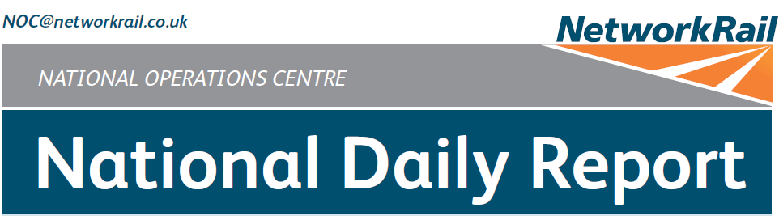



***DATE OF REPORT: NOC MANAGER 0700 – 1900:***

***NOC MANAGER 1900 – 0700:***

***DUTY CONTROLLER 0630 – 1830:***

***DUTY CONTROLLER 1830 – 0630:***

***SUPPORT CONTROLLER 0630 – 1830:***

***SUPPORT CONTROLLER 1830 – 0630:***

***LONDON CONTROLLER 0700 – 1900:***

***LONDON CONTROLLER 1900 – 0700:***

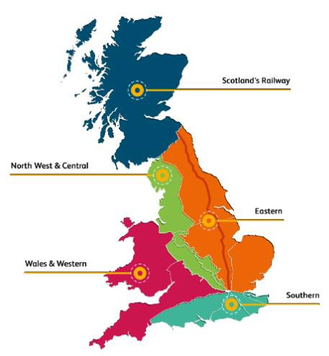

Sunday 23rd February 2020 Mark Elkin

David Burnett Mark Robinson Ian Swain Graham McIntosh Karl Biswell David Newton Martin Dineen

# TABLE OF CONTENTS

1. WRONG SIDE FAILURE REPORTS 3
2. SIGNALS PASSED AT RED (CATEGORY ‘A’) 3
3. DERAILMENTS 3
4. COLLISIONS 3
5. TRAIN OR VEHICLE RUNAWAY 3
6. OPERATIONAL INCIDENTS 3
7. TRAINS WITH STRANDED PASSENGERS 4
8. SIGNIFICANT POSSESSION PROBLEMS 4
9. FATALITIES 4
10. INJURIES/ASSAULTS 4
11. NEAR MISSES 5
12. RAILWAY CRIME 5
13. STATION OVERRUNS 5
14. BROKEN RAILS/TRACK DEFECTS 5
15. POWER FAILURES 5
16. POINTS FAILURES 6
17. SIGNALS/SIGNALLING SYSTEMS FAILURES 6
18. TRACK CIRCUIT & AXLE COUNTER FAILURES 6
19. BRIDGE STRIKES 7
20. ROAD VEHICLE INCURSIONS (NON-LEVEL CROSSINGS) 7
21. TRACTION FAILURES 7
22. WEATHER-RELATED PROBLEMS 7
23. FIRES 8
24. WILD REPORTS & HABD ACTIVATIONS 9
25. GROUP STANDARDS GE/RT8250 & GO/RT3350 10
26. TPWS 10
27. MISCELLANEOUS 11
28. REVIEW TABLE 11
29. REAL TIME PERFORMANCE FIGURES 12

None.

***01 WRONG SIDE FAILURE REPORTS***

***02 SIGNALS PASSED AT RED (CATEGORY ‘A’)***

## Eastern (North & East) – CCIL 2099741 / Fault No. 788800

At 1757, 4D71, GB Railfreight, 1534 Hexthorpe – Rylstone Tilcon, passed L3971 signal on the Down Shipley Main line at Shipley station at red by 15 metres. When questioned, the driver stated a loss of concentration (group 2 cause). After consultation with GB Railfreight, the driver was judged fit to continue and was met on arrival at Leeds, where the on-call Driver Manager took the train forward to destination.

|  |  |  |  |  |  |  |  |
| --- | --- | --- | --- | --- | --- | --- | --- |
| TRUST 805691 FPET | | | | | | | |
| Cancelled | 0 | Part Cancelled | 0 | Trains Delayed | 5 | Minutes | 161 |

***03 DERAILMENTS***

None.

***04 COLLISIONS***

None.

***05 TRAIN OR VEHICLE RUNAWAY***

None.

***06 OPERATIONAL INCIDENTS***

## Wales and Western (Wales) – CCIL 2099585 / Fault No. 461350

At 0930, it was advised that an RRV working within WW WON 48, Item 221, due to be handed back at 0220 (Mon), had cut through a 650v cable at Tremains, no loss of signalling was reported. The Machine Controller employed by Ganymede left site shortly after without consent, and before investigations had started. A Level 1 investigation into the incident was commenced. At 1401, Ganymede advised that they had suspended the Machine Controllers Sentinel Card. Investigations were ongoing at the close of this Report.

## Southern (Kent) – CCIL 2099718 / Fault No. 464715

At 1703, the Engineering Supervisor working within KS WON 48, Item 6, reported that an RRV had struck rail over road Bridge HHH/519 between Herne Hill and Tulse Hill. The Herne Hill Mobile Operations Manager and a Bridge Strike Engineer (BSE) were summoned to site. The Mobile Operations Manager advised at 1737 that there was a pillar at risk of falling into the car park below the structure. An Investigating Officer was appointed and decided that ‘for cause’ screening was not required. The BSE was on site at 1906, reporting that approximately one ton of unstable brickwork required removal from the structure. Remedial work was undertaken by 0006 to make the bridge safe and repair works have been planned.

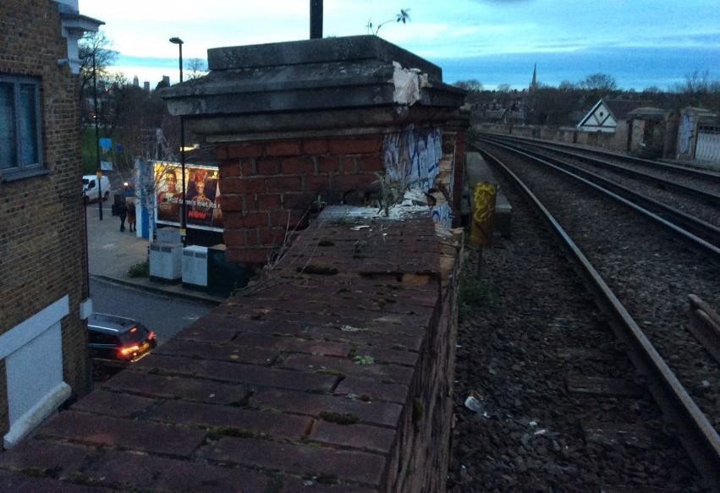

***07 TRAINS WITH STRANDED PASSENGERS***

|  |  |  |  |  |  |
| --- | --- | --- | --- | --- | --- |
| ***Region / Route*** | ***Train*** | ***Since*** | ***Between*** | ***OUTCOME*** | ***CCIL*** |
| Nil |  |  |  |  |  |

***08 SIGNIFICANT POSSESSION PROBLEMS***

None.

***09 FATALITIES***

None.

***10 INJURIES/ASSAULTS***

## Scotland - CCIL 2099459

At 0305, it was reported that a member of P’Way staff at Barassie Yard had fallen onto their right hand after misplacing their footing whilst stepping down from the rear of their vehicle. The person was conveyed to hospital to have their injuries assessed.

## Eastern (East Coast) – CCIL 2099711

At 1655, the driver of 1H04, Rail Operations Group, London Kings Cross - Hull, reported that the train may have struck a person on the Down Main line at Penney’s (UWC) level crossing between Bawtry emergency crossover and Loversall Carr Jn. All lines were blocked, the driver reported at 1707 that following an examination of the train, they had found no evidence of an impact. BT Police (ref. 392) reported at 1714 that they were with an intoxicated person at the crossing who had received minor injuries after falling over. The RIO confirmed all BT Police were clear of the running lines and the intoxicated person was inside an ambulance, allowing all lines to open at 1727.

|  |  |  |  |  |  |  |  |
| --- | --- | --- | --- | --- | --- | --- | --- |
| TRUST 805566 XQIA | | | | | | | |
| Cancelled | 0 | Part Cancelled | 1 | Trains Delayed | 55 | Minutes | 498 |

***12 RAILWAY CRIME***

None.

***13 STATION OVERRUNS***

## North West and Central (C) – CCIL 2099815

At 2306, 1G69, Chiltern, 2208 London Marylebone – Birmingham Snow Hill, formed by unit 168108, comprising three coaches in all, overran Bicester North station by one coach length, returning to the station with permission. The driver stated that the overrun was due to forgetting the booked stop. The driver was fit to continue.

|  |  |  |  |  |  |  |  |
| --- | --- | --- | --- | --- | --- | --- | --- |
| TRUST 806108 THOA | | | | | | | |
| Cancelled | 0 | Part Cancelled | 0 | Trains Delayed | 1 | Minutes | 11 |

***14 BROKEN RAILS/TRACK DEFECTS***

## Eastern (North & East) – CCIL 2099607 / Fault No. 788776

At 1109, the driver of 9M07, TransPennine Express, 0903 Newcastle Central - Liverpool Lime Street reported a track defect on the Up Huddersfield line between Thornhill LNW Junction and Mirfield East Junction. P’Way staff were mobilised to site. The implemented contingency plan resulted in a reduction in TransPennine Express services between Liverpool Lime Street and York. Staff arrived on site at 1322 and were granted a Line Blockage to undertake an inspection. At 1345 the Line Blockage was rescinded and the P’Way staff confirmed a dip in the track and that further Line Blockages were required. Services were cautioned until a suitable margin was found at 2028, when repair work was carried out to allow the site to be handed back with a 20 mph ESR.

|  |  |  |  |  |  |  |  |
| --- | --- | --- | --- | --- | --- | --- | --- |
| TRUST 805179 IQGG | | | | | | | |
| Cancelled | 5 | Part Cancelled | 14 | Trains Delayed | 142 | Minutes | 1200 |

***15 POWER FAILURES***

None.

## Eastern (East Coast) – CCIL 2099525 / Fault No. 788755

At 0737, the Shift Signalling Manager at Leeds sub ROC advised that No.806 points at the North end of York station had failed with no Normal detection, resulting in no access to platforms 8 & 9. S&T staff arrived at 0805 and advised that a replacement micro switch was required. The S&T team returned with the replacement part and were granted a Line Blockage at 0913. At 1019 the Line Blockage was withdrawn with the points secured in the Normal position with detection. An additional 30-minute Line Blockage was required to complete the repair but there would be no access to or from platforms 9, 10 & 11 during the Line Blockage. A suitable margin was arranged by re-platforming services and the Line Blockage was granted at 1224 and given up at 1310, with additional repair work carried out until 1343, when normal signalling resumed. At 1414 it was reported that the points had again failed with no Normal detection. This resulted in Y304 signal on the Up Fast line reverting from green to red as 9M11, TransPennine Express, 1133 Edinburgh Waverley – Liverpool Lime Street approached. The driver was unable to stop and passed the signal at red. The driver was fit to continue. S&T staff arrived at 1513 and were granted a Line Blockage to rectify the fault. By 1539 the Line Blockage was rescinded, and normal signalling resumed. At 1548, detection of the points again failed, S&T staff reported there was a faulty clamp lock body that needed replacing. After returning to the depot for the part, a further Line Blockage was taken at 1714 and a new clamp lock body was fitted, allowing normal working to resume at 1735.

|  |  |  |  |  |  |  |  |
| --- | --- | --- | --- | --- | --- | --- | --- |
| TRUST 804902 IQIE | | | | | | | |
| Cancelled | 2 | Part Cancelled | 5 | Trains Delayed | 184 | Minutes | 1908 |

***17 SIGNALS/SIGNALLING SYSTEMS FAILURES***

None.

***18 TRACK CIRCUIT & AXLE COUNTER FAILURES***

## Southern (Sussex) – CCIL 2099666 / Fault No. 464701

At 1459, the driver of 9A37, Arriva Rail London, 1413 Highbury & Islington – Crystal Palace, who had been cautioned for the failure of track circuits ‘MU’ & ‘MV’ which failed at 1350, reported a crack in the rail on the Down Sussex Slow line between Forest Hill and Sydenham. The following service was cautioned, with the driver advising that there was a track defect present, with a visible dip in the railhead. Following services were cautioned at 20 mph and London Bridge P’Way staff were summoned to site. Arriva Rail London services were terminated/started from Surrey Quays to ease congestion through the area. Normal signalling was authorised at 1640, after no defect was identified and the track circuits had gone clear. However, both track circuits were intermittently failing again from 1653. In response, services were cautioned from TL593 signal, with TL597 cleared on approach. S&T and P’Way staff advised at 1710 that there was no obvious defect with the Insulated Block Joint (IBJ), testing was continued by the night turn S&T team, which was ongoing at the close of this Report.

|  |  |  |  |  |  |  |  |
| --- | --- | --- | --- | --- | --- | --- | --- |
| TRUST 805483 IQM1 | | | | | | | |
| Cancelled | 31 | Part Cancelled | 43 | Trains Delayed | 87 | Minutes | 505 |

|  |  |  |  |  |  |  |  |
| --- | --- | --- | --- | --- | --- | --- | --- |
| ***Region / Route*** | ***Time*** | ***Location*** | ***Bridge No.*** | ***Dispensation*** | ***NWR*** | ***CCIL*** | ***TRUST*** |
| Eastern (EM) | 1053 | Matlock Road | SPC8/59 | DA | 1117 | 2099591 | No delay. |
| North West and Central (WCMLS) | 1118 | Watford | LEC1/61 | G | 1118 | 2099605 | No delay. |
| Eastern (N&E) | 1746 | Dewsbury | MDL1/24 | LV | 1802 | 2099735 | 805623 XQGL = 15 trains = 98 mins |

***20 ROAD VEHICLE INCURSIONS (NON-LEVEL CROSSINGS)***

None.

***21 TRACTION FAILURES***

None.

***22 WEATHER-RELATED PROBLEMS***

## North West and Central (NW) – CCIL 2098959 / Fault No. 883076

With reference to the item in this section of yesterday’s Report concerning high water levels in Summit Tunnel. At 0151 (Sun), as a result of the water levels dropping, Preston PSB Shift Signalling Manager advised that track circuit ‘688’ had gone clear, allowing normal signalling to resume.

|  |  |  |  |  |  |  |  |
| --- | --- | --- | --- | --- | --- | --- | --- |
| TRUST 802376 IQFP (since 22/02/20) | | | | | | | |
| Cancelled | 0 | Part Cancelled | 0 | Trains Delayed | 169 | Minutes | 1267 |

## North West and Central (NW) – CCIL 2099140 / Fault No. 883170

At 0722, staff working between Sutton Weaver G/F and Weaver Junction reported floodwater above the railhead on both the Up and Down Ditton lines. Off Track and P’Way staff were mobilised to site, train crew route knowledge was confirmed for Avanti West Coast services departing Liverpool Lime Street for the diversion route via Chat Moss. At 0733, it was confirmed the water level was below rail height and 5P10, Avanti West Coast, 0813 Edge Hill – Preston, was utilised to examine the line and stated that the ballast had not been dislodged. The P’Way Section Manager (PWSM) imposed a 20 mph ESR on both the lines at 0846 and reported that the water was flowing over the top of an aqueduct and down the embankment. The PWSM advised that AMCO staff had been mobilised to site with pumping equipment. The pumps were installed, and by 1504 linespeed had been restored on the Up Ditton line. The PWSM observed a service through on the Down Ditton line at 50 mph with no issues, allowing normal signalling to resume at 1822. The pumps and AMCO staff remained on site overnight.

|  |  |  |  |  |  |  |  |
| --- | --- | --- | --- | --- | --- | --- | --- |
| TRUST 804918 IQFK | | | | | | | |
| Cancelled | 0 | Part Cancelled | 0 | Trains Delayed | 64 | Minutes | 528 |

## Wales and Western (Western) – CCIL 2099704 / Fault No. 461380

At 1620, the route proving train operating between Machynlleth and Shrewsbury identified an embankment washout/slip site at 36m 75ch, between Munllyn (UWC) and Fron Junction. Mobile Operations Manager, P’Way and Earthworks Engineer attended site and reported at 1933 that the line should remain blocked due to the proximity of the embankment slip to the running line. The line is likely to remain blocked until Tuesday 25th February whilst rectification works are completed, with a daylight inspection planned for 0830 Monday 24th February.

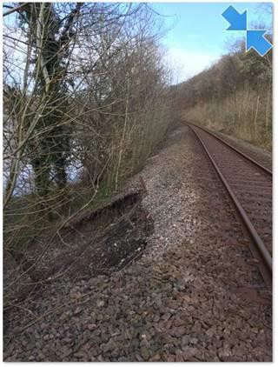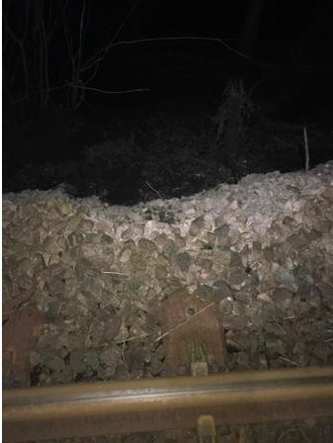

|  |  |  |  |  |  |  |  |
| --- | --- | --- | --- | --- | --- | --- | --- |
| TRUST 805524 XQWS | | | | | | | |
| Cancelled | 0 | Part Cancelled | 0 | Trains Delayed | 2 | Minutes | 51 |

***23 FIRES***

None.

## Disconnected Hot Axle Box Detectors:

|  |  |  |  |  |  |  |  |  |  |
| --- | --- | --- | --- | --- | --- | --- | --- | --- | --- |
| *Region / Route* | *Location* | *Line* | *Date Disconnected* | *Reason* | *TOC’s/ FOC’s*  *advised* | *Planned Restoration Date* | *Date Restored* | *Function* | *Fault Number* |
| Eastern (Anglia) | Brentwood | Down Electric | 10/03/16 | Offline | Y | Awaiting update |  | IM | 234632 |
| Eastern (Anglia) | Brentwood | Down Main | 10/03/16 | Offline | Y | Awaiting update |  | IM | 234632 |
| Eastern (Anglia) | Margaretting | Up Main | 19/09/19 |  | Y | Awaiting update |  | IM | 298498 |
| Eastern (EM) | Branston | Up Tamworth | 18/02/20 | Defective | Y | Awaiting update |  | IM | 154332 |
| Eastern (EM) | Chiltern Green | Down Slow | 11/07/19 | Defective | Y | Awaiting update |  |  | 148559 |
| Eastern (EM) | Napsbury | Up Fast | 11/07/19 | Defective | Y | Awaiting update |  |  | 148559 |
| Eastern (EM) | Langley Mill | Up & Down Erewash Slow | 13/02/20 | SK4 fault | Y | Awaiting update | 18/02/20 | IM | 1564199 |
| Eastern (LNE) | Barkston | Up Main | 01/04/19 | Removed for P’Way work | Y | Awaiting update |  |  |  |
| NW & Central (NW) | Bolton-le- Sands | Up Main | 25/08/19 | Integrity Fault | Y | Awaiting update |  |  | 863361 |
| NW & Central (NW) | Hest Bank | Up Main | 25/08/19 | Integrity Fault | Y | Awaiting update |  |  | 863360 |
| NW & Central (NW) | Low Mill | Down Main | 26/11/14 | Awaiting replacement | Y | Awaiting update |  | IP | 671852 |
| NW & Central (NW) | Sutton Weaver | Down Main |  |  | Y | Awaiting update |  |  |  |
| NW & Central (WCMLS) | Bradnocks Marsh (Coventry) | Up Main | 29/12/19 | Integrity | Y | Awaiting Update |  |  | 872142 |
| NW & Central (WCMLS) | Castlethorpe | Up Fast | 27/11/18 | Error code 6.0 | Y | Awaiting Update |  | IM | 832410 |
| NW & Central (WCMLS) | Harecastle | Up Main | 01/04/19 | Rail incorrectly drilled | Y | Awaiting Update |  |  |  |
| NW & Central (WCMLS) | Penkridge | Up Penkridge | 04/11/19 | Integrity | Y | Awaiting Update |  |  | 870982 |
| Wales & Western (Wales) | Dainton | Down Main | 17/11/19 | Defective PC | Y | Awaiting Update |  | IM | 453850 |
| Wales & Western (Wales) | Pembrey | Up | 17/02/20 | Constantly alarming | Y | Awaiting Update |  | IM | 460854 |
| Wales & Western (Western) | Cogload | Down Main | 25/01/20 |  | Y |  |  |  | 458740 |
| Wales & Western (Western) | Treverrin | Down Main | 01/07/19 |  | Y | Awaiting Update |  |  | 443474 |
| Wales & Western (Western) | Twerton | Down Main | 19/11/19 |  | Y | Awaiting Update |  |  | 454030 |
| Wales & Western (Western) | Warminster | Up Salisbury | 22/01/20 | Defective | Y | Awaiting Update |  |  | 458111 |

## Disconnected Wheel Impact Load Detectors:

|  |  |  |  |  |  |  |  |  |  |
| --- | --- | --- | --- | --- | --- | --- | --- | --- | --- |
| *Region / Route* | *Location* | *Line* | *Date Disconnected* | *Reason* | *TOC’s/ FOC’s*  *advised* | *Planned Restorati on Date* | *Date Restored* | *Function* | *Fault Number* |
| Eastern (EC) | Sessay | Up Slow | 18/06/2019 | Calibration |  |  |  | IM |  |
| North West & Central (NW) | Heaton Chapel | Up Slow | 30/07/2019 | Calibration |  |  |  | IM |  |
| Southern (Kent) | Sevington | Down Main | 25/04/2018 | PC Failure |  |  |  | IM |  |
| Southern (Kent) | Sevington | Up Main | 09/08/2018 | PC Failure |  |  |  | IM |  |
| Southern (Kent) | Swanley | Up Slow | 02/04/2019 | Calibration |  |  |  | IM |  |
| Scotland | Howwood | Up | 20/01/2019 | HOBC |  |  |  | IM |  |
| Wales & Western (Western) | Urchfont | Up | 11/04/2019 | PC Failure |  |  |  | IM |  |
| Wales & Western (Western) | Urchfont | Down | 11/04/2019 | PC Failure |  |  |  | IM |  |

***25 GROUP STANDARDS GE/RT8250 & GO/RT3350***

None.

***26 TPWS***

|  |  |  |  |  |  |  |  |  |
| --- | --- | --- | --- | --- | --- | --- | --- | --- |
| ***Region*** | ***Route*** | ***Train*** | ***Signal/PSR/ Buffer Stop*** | ***Line/Platform*** | ***Location*** | ***Speed (reported)*** | ***Speed (set)*** | ***CCIL*** |
| NW&C | WCMLS | 1G80, West Midlands Trains, 2134 Liverpool Lime Street – Birmingham New Street | 60 mph PSR | Up line | Bushbury Junction | 90 | 100 | 2099816 |

## Scotland - CCIL 2099300

With reference to the item in this section of yesterday’s Report concerning the gas leak near the railway between Singer and Dalmuir: Numerous attempts were made to reduce the gas pressure so that engineers could begin repair, however, difficulties were experienced with the valves as one of them was seized. By 1902 staff had managed to release both of the valves to begin reducing the gas pressure. The leak was repaired by 2211. By 2240 all testing had been completed, the OLE energised at 2311, allowing normal signalling to resume.

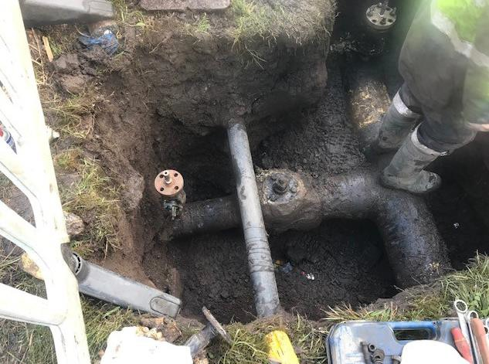

|  |  |  |  |  |  |  |  |
| --- | --- | --- | --- | --- | --- | --- | --- |
| TRUST 804314 XQLY (since 22/02/20) | | | | | | | |
| Cancelled | 0 | Part Cancelled | 2 | Trains Delayed | 19 | Minutes | 226 |

***28 REVIEW TABLE***

|  |  |  |
| --- | --- | --- |
| ***INCIDENT*** | ***TODAY’S TOTAL*** | ***DAYS SINCE LAST INCIDENT*** |
| **PASSENGER ACCIDENTAL FATALITIES** | **0** | **445** |
| **RAILWAY WORKFORCE FATALITIES** | **0** | **71** |
| **SIGNALS PASSED AT RED (CATEGORY ‘A’)** | **1** | **0** |
| **SIGNALS PASSED AT DANGER (ERROR/TECHNICAL SIGNAL REVERSION)** | **1** | **0** |
| **DERAILMENTS** | **0** | **2** |
| **TRAIN COLLISIONS** | **0** | **10** |
| **TRAINS STRIKING ROAD VEHICLES** | **0** | **26** |
| **ENVIRONMENTAL INCIDENTS** | **0** | **12** |

